

REQUIREMENT PROCESS

**Version1.0**

**Trịnh Như Phương**

**<05/11/2019>**

**VERSION HISTORY**

|  |  |  |  |  |  |
| --- | --- | --- | --- | --- | --- |
| **Version #** | **Implemented**  **By** | **Revision**  **Date** | **Approved**  **By** | **Approval**  **Date** | **Reason** |
| 1.0 | Trịnh Như Phương | 05/11/2019 | 05/11/2019 | 05/11/2019 |  |
|  |  |  |  |  |  |
|  |  |  |  |  |  |
|  |  |  |  |  |  |

Table of Contents

Table of Contents

1. Introduction 4

1.1. The purpose and scope of the document 4

1.2. Objects towards 4

1.3. List of terms and acronyms 4

2. Requirement Management Process 5

2.1. Requirement Management Process 5

**2.1.1. Process** 5

**2.1.2. Roles and Responsibilities** 5

**2.1.3. Description** 6

2.2. Analysis process 8

**2.2.1.** **Process** 8

**2.2.2.** **Description** 9

2.3. Specification process 10

**2.3.1.** **Process** 10

**2.3.2.** **Description** 10

2.4. Validation process 12

**2.4.1.** **Process** 12

**2.4.2.** **Description** 12

3. Template for apply process 13

4. Tools 14

5. Reference document 14

# Introduction

## The purpose and scope of the document

This document describes an overview of the process of collecting customer requirements, resources, stakeholder information, documentation, and environmental requirements analysis of the project.

## Objects towards

|  |  |  |
| --- | --- | --- |
| No | Readers | Reason for reading |
| 1 | Project Manager | Understand and understand the project requirements in order to process and manage project requirements in certain stages of development. |
| 2 | Mentor | Review and guide the development process required by the project |
| 3 | Requirements Leader | Use this document to guide, control, and track the collection phase requirements for the project. |
| 4 | Requirement Engineer | Read document to know Requiment process, role and responsibility and follow it to work in Requirement phase. |

## List of terms and acronyms

|  |  |
| --- | --- |
| Terms | Define |
| Ver | Version |
| NMS | Network Monitoring System |
| SRS | Software Requirement Specification |
| ConOp | Concept of operation |
| URD | User Requirement document |
| RE | Requirements Engineering |
| AR | Architect |
| SH | Stakeholder |
| BRD | Business Process Document |
| PFP | Proposed Function Document |
| PT | Prototype |
| CO | Concept of Operation Document |

# Requirement Management Process

## 2.1. Requirement Management Process

### **2.1.1. Process**

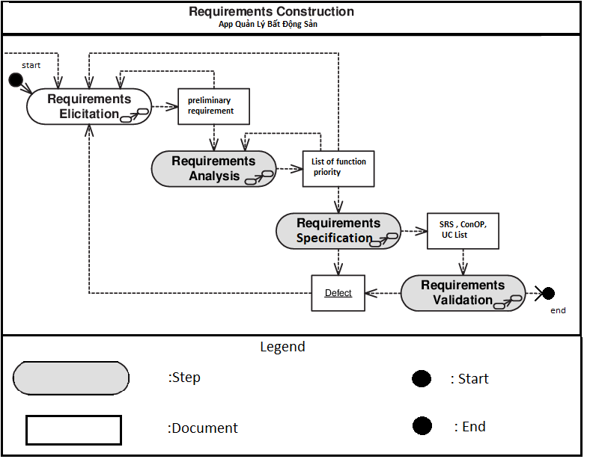

### **2.1.2. Roles and Responsibilities**

|  |  |
| --- | --- |
| Roles | Responsibilities |
| Requirement leader | Planning for the required collection phase and management based on it  Schedule customer interviews  Determine the progress of the required collection phase and update the content of the ongoing request.  Prepare all templates to use during project requirements collection  Track and evaluate the work of the members at the end of each stage.  Consolidate and release all documents during this period. |
| Requirement Engineers | Flexibly use the techniques of gathering requirements into actual operation  Cooperate with stakeholders to develop the requirements  Define user requirements, create models, forms, and documentation requirements.  Review the requirements are correct, appropriate and completed.  Converts user requests into functional requirements of the software. |
| Stakeholders | More important than a regular user  Provides documentation requests and endorsements once completed. |
| Architect | Provides detailed information about the needs of users, business operations and data  Demonstrates the needs of users who can participate in the system  Identify the problems that integrate hardware, software, and systems.  Ensure requirements close links with product orientation.  Exchange with experts who have in-depth knowledge of the field of data collection and analysis.  Review and re-evaluate the documents requested to ensure that the materials summarized are representative of the requirements of the system user. |
| Requirement Reviewer | Evaluate, review the documentation required of the project to ensure that the document fully reflects the needs of the user. |

### **2.1.3. Description**

|  |  |  |  |  |
| --- | --- | --- | --- | --- |
| Steps | Describe | Input | Output | Role attend |
| Elicitation | Understand customer requirements, user requirements, software and system development, and system development activities:   * Identify stakeholders * Ability to listen * Ability to ask questions to collect as much information as possible from the customer. * Have the ability to communicate * Ability to explore, interest in new things * Use prototype templates * Use Interviews / Surveys | * Initial Requirement * Commitment | * BRD * PFD | * Requirement Leader. * Requirement engineer. * Stakeholders |
| Analyze | * This is the process of deriving the system requirements through observation of existing systems, discussions with stakeholders, etc. This may involve the development of one or more system models and prototypes that can help us understanding the system to be specified. | * BRD * PFD | * Proposal document. * Prototype. | * Requirement Leader. * Requirement engineer. |
| Specification | * It’s the activity of writing down the information gathered during the elicitation and analysis activity into a document that defines a set of requirements. Two types of requirements may be included in this document | * Proposal document. * Prototype. | * Concept of Operation * SRS * Use case. | * Requirement Leader. * Requirement engineer. * Customer |
| Validation | * It’s the process of checking the requirements for realism, consistency and completeness. During this process, our goal is to discover errors in the requirements document. When errors are found, it must be modified to correct these problems. | * Concept of Operation * Prototype (draft) * Use case Diagram * SRS | * Proposal * Concept of Operation * Use case Diagram * Prototype * SRS * (CON-FIRMED) | * Requirement Leader. * Requirement engineer. * Requirement Architects |

## Analysis process

### **Process**

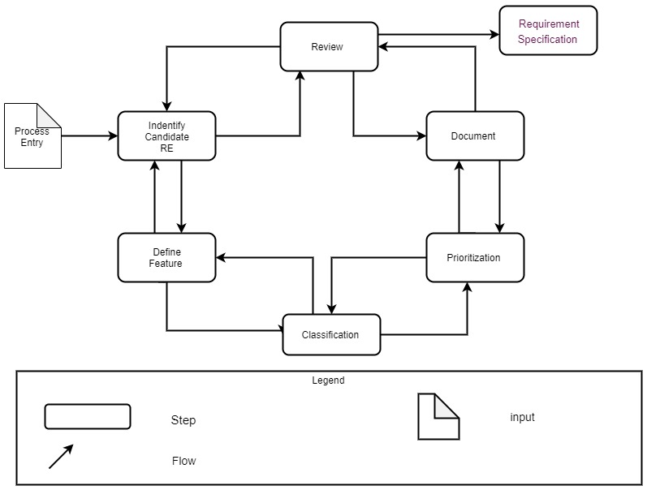

### **Description**

|  |  |  |  |  |
| --- | --- | --- | --- | --- |
| Steps | Describe | Input | Output | Role attend |
| Identify  Candidate  RE | Identify potential requirements to identify what is required by the customer / user.  The stakeholder needs analysis process prepares and defines the concept of system corruption as well as the requirements for building software.  The requirements analysis process also focuses on analyzing the interrelation and priority levels between requirements to determine the reasonableness of priority in solving problems in the system.  Use the 5W + H questions to analyze the requirements. | * Business process * Proposed function |  | Requirement engineer. |
| Define Feature | The requirements analysis process also focuses on analyzing the interrelation and priority levels between requirements to determine the reasonableness of priority in solving problems in the system.  Define the function / characteristics the system will be developed. | * Business process * Proposed function * (Which are analyzed) | List of feature/function (Draft) | Requirement engineer. |
| Classification | Requirements are usually classified into two broad categories, namely—Functional requirements which specify the properties and the behaviour of the information system that must be developed, and the Non‐functional requirements | * Business process * Proposed function   (Which are analyzed) |  | Requirement engineer. |
| Prioritization | determine the priority of the function | * Business process * Proposed function   (Which are analyzed) | List function of priority | Requirement engineer. |
| Document | Document all information that you have analyzed | REs overview which are analyzed. | * Prototype | Requirement engineer. |
| Review | RL will review and re-evaluate the contents of the document prior to release. | * Proposal * Use case Diagram * Prototype | * Proposal * Prototype (new version) | Requirement Leader |

## Specification process

### **Process**

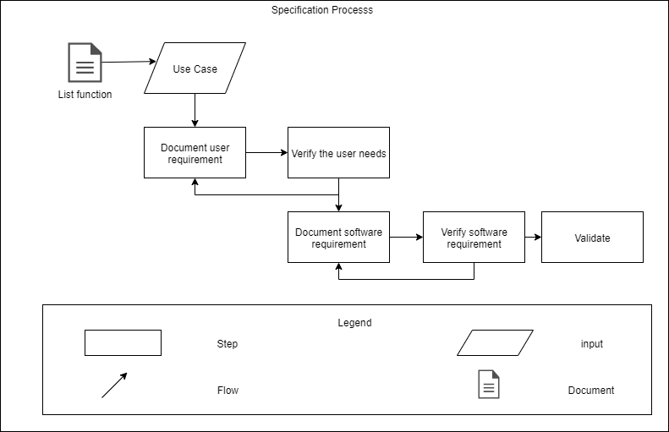

### **Description**

|  |  |  |  |  |
| --- | --- | --- | --- | --- |
| Steps | Describe | Input | Output | Role attend |
| Use Case | Use case describes the typical interaction between external user (actor) and the system. It shows the behavior of the system to the outside, in a certain context, from the perspective of the user. | * List function |  | Requirement engineer |
| Document user requirement | A User requirements document is a record of requirements written for users that describes what users need and why they need it. | * Use case |  | Requirement engineer. |
| Verify the user needs | something looks like a user need, it doesn’t mean any users actually need it. It doesn’t mean your site needs it. It doesn’t mean what you write will meet the need in a way users can relate to.This is why you need to ‘verify’ user needs before acting on requests to meet them. | Usecase |  | Requirement Leader |
| Document software requirement | A Software requirements document is a record of requirements written for developers and allows them to design, develop and test the software solution. | * Use case * Prototype |  | Requirement engineer. |
| Verify software requirement | It would imply to verify if the specifications are met by running the software but this is not possible . Only by reviewing its associated artifacts, someone can conclude if the specifications are met. |  | •Concept.  •Prototype.  •SRS | Requirement Leader |

## Validation process

### **Process**

### 

### **Description**

|  |  |  |  |  |
| --- | --- | --- | --- | --- |
| Steps | Describe | Input | Output | Role attend |
| Select Requirement  Validation techniques | After confirming the request, we will confirm the request again by the techniques | * Proposal * Use case * Prototype * Concept. * Prototype. * SRS |  | Requirement engineer. |
| Ensure Adequate  User Involvement | Formal reassessment of the defined processes for the implementation teams, in which each group is assigned different tasks and roles over a specified period of time. |  |  | Requirement engineer. |
| Validate the  REs | Review request evaluation process:   * Identify part of document to review. * Identify the evaluator. * Plan, explain role, responsibility and authority of the evaluator. * Use checklist to test, analyze the document * Review the identified processes to provide feedback. * Edit the document based on the feedback, feedback rating. | * Proposal * Use case * Prototype * Concept. * Prototype. * SRS |  | Stakeholder |
| Revise the  REs  Documentation | SE changes and defines goals and objectives for stakeholders to ensure consistency in understanding, thinking and system requirements, functions of system software. | * Proposal * Use case * Prototype * Concept. * Prototype. * SRS |  | Requirement engineer. |

# Template for apply process

|  |  |  |  |
| --- | --- | --- | --- |
| Stt | Template | Describe | Place |
| 1 | Requirement Management Plan | This document aims to provide a detailed plan for demand management strategies, workflow management, human resources management and the environment to analyze project requirements. |  |
| 3 | Concept of Operation document | Provides an overview of the system, related issues, solutions, system constraints, features, and functions from a user perspective. |  |
| 4 | Use case document. | The content of this document is that the Use Case contexts are built |  |
| 5 | Software Requirement Specification (SRS) | Provides an overview of the system, related issues, solutions, system constraints, features, functions from a technical perspective. |  |

# Tools

Microsoft word 2016: to write this document

Draw.io : to draw use case examples.

# Reference document